----------

URL : https://www.facebook.com/

NOTE: Print all the options in year using getAttirubute() method

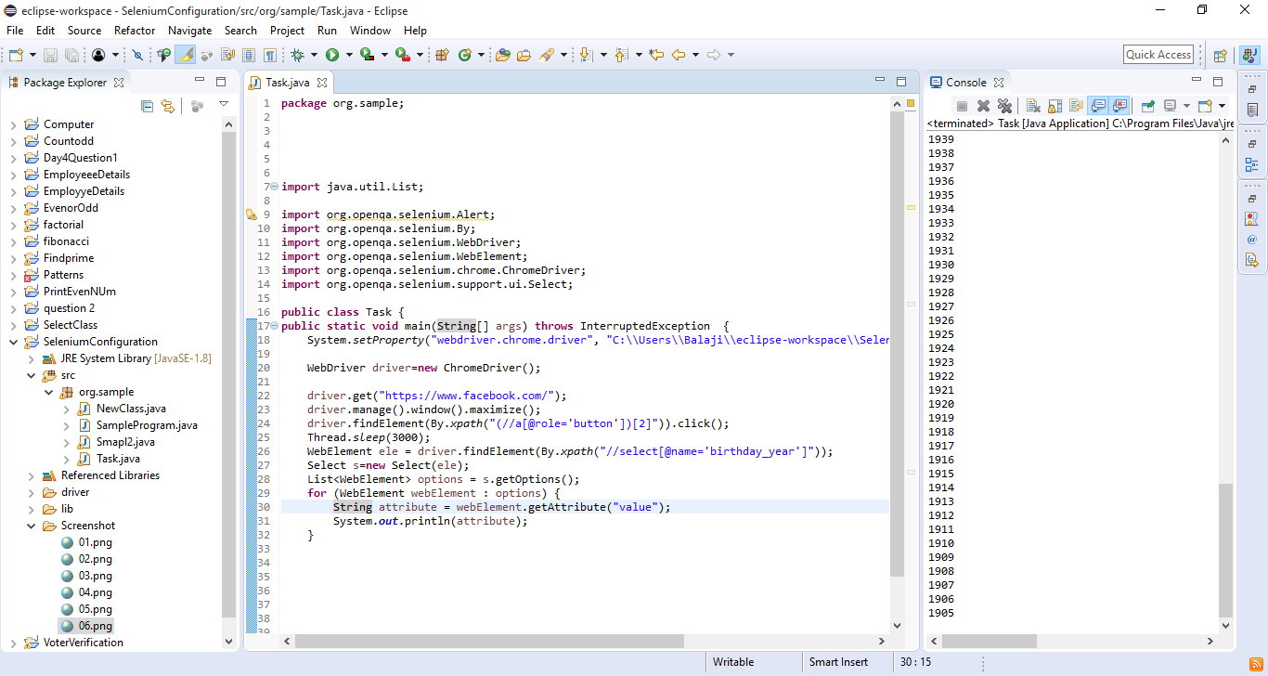

----------

URL : https://www.facebook.com/

NOTE: Print all the options in month using getText() method

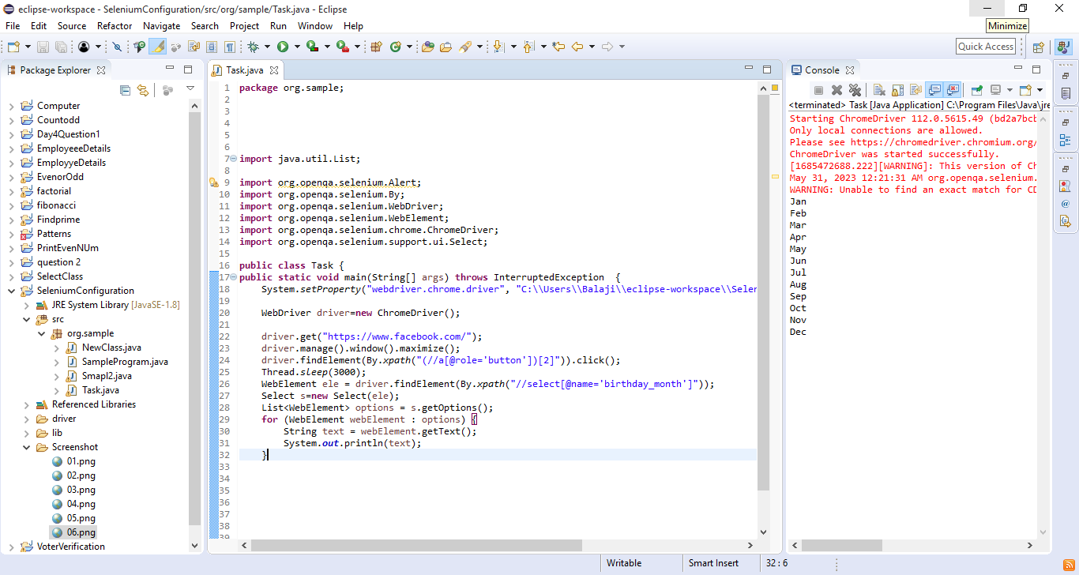

-----------

URL : https://www.facebook.com/

NOTE: print the even dates

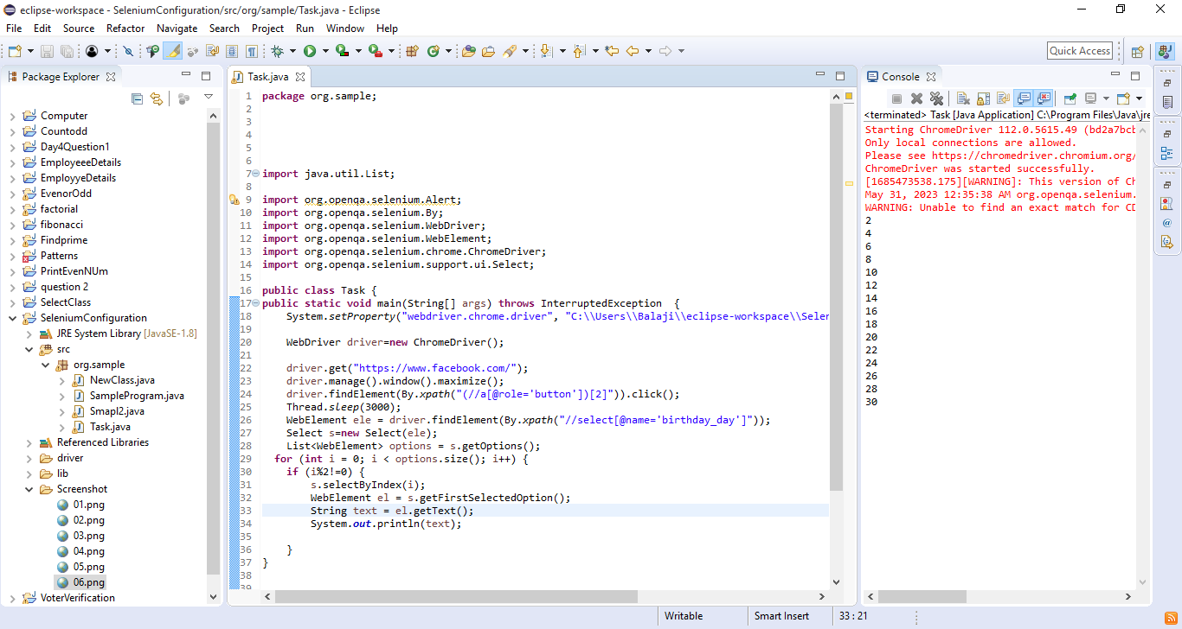

-----------

URL : http://demo.guru99.com/test/newtours/register.php

NOTE: print all the option of country using getText() methods

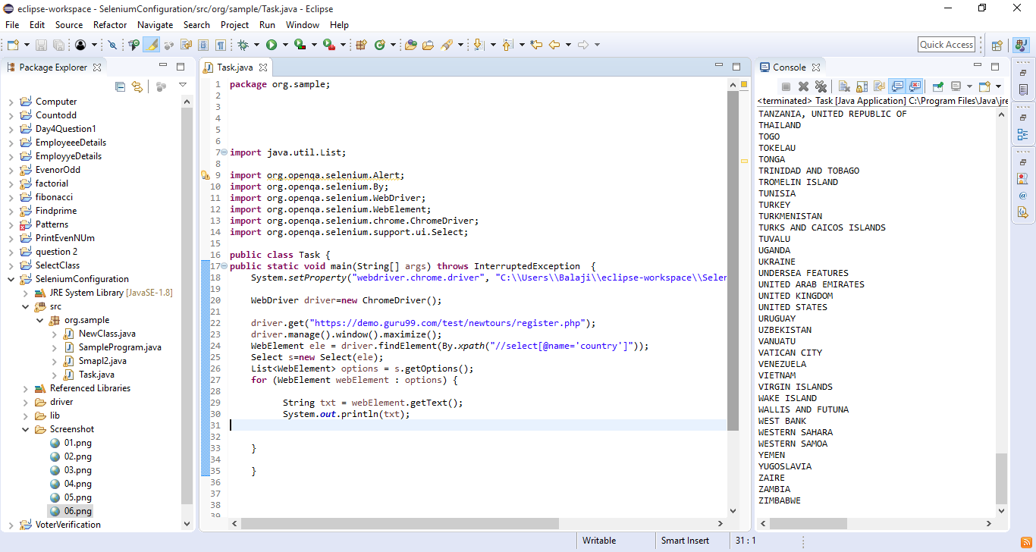

-----------

URL : http://demo.guru99.com/test/newtours/register.php

NOTE: print all the option of country using getAttribute() method

Register Form

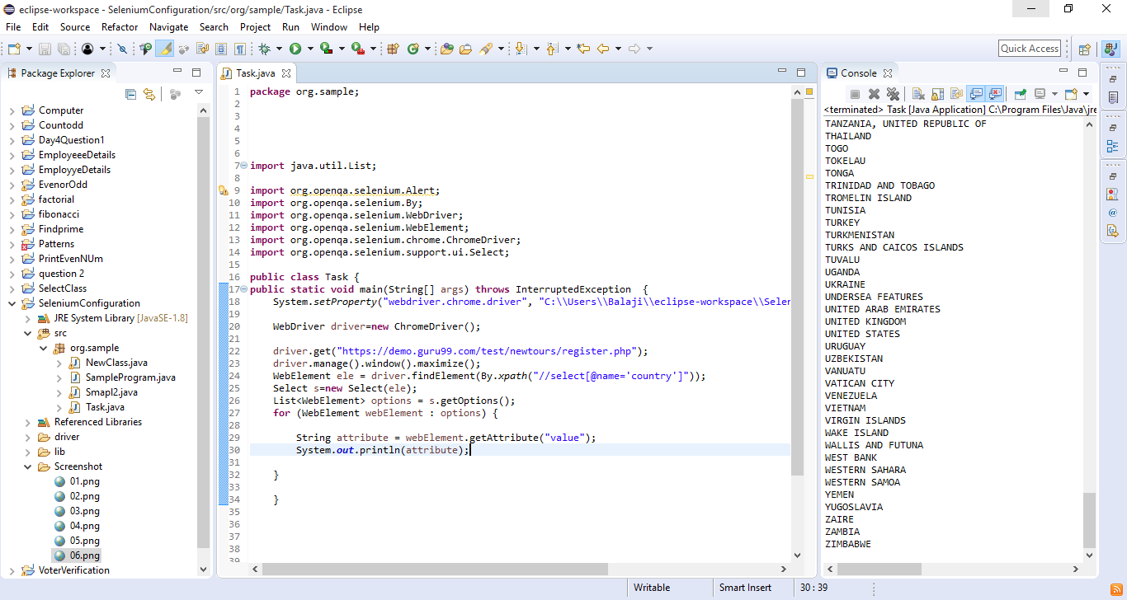

-----------

URL : http://output.jsbin.com/osebed/2

NOTE: Select Even Option availble in fruits

Find out number of option not selected

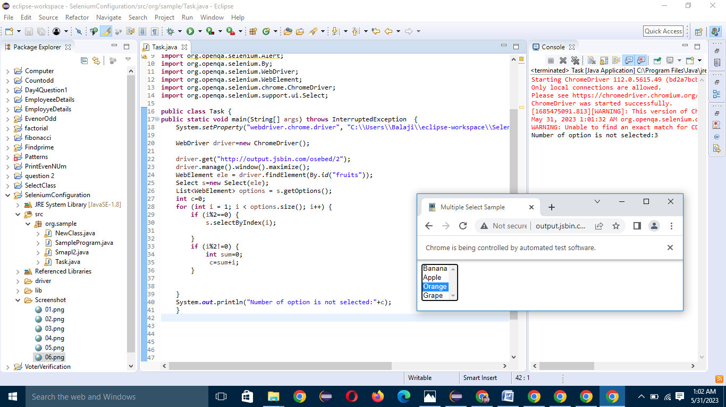

-----------

URL : http://output.jsbin.com/osebed/2

NOTE: Select All availble in fruits

Print first selected option

